 | 16.2 Editors - Dope Sheet - Channel list
Table of content
Dopesheet Editor - Channel List 1
Hotkeys 1
Search field 1
Expand / collapse triangle 2
Object type Icon 2
Channel name 2
Enable F-Curve Modifiers 2
Mute Channel 2
Lock Channel 2
Slider values 2
Shape key values 3
Opacity values 3
Mask Layer 3
Onion Skinning 3

Dopesheet Editor - Channel List
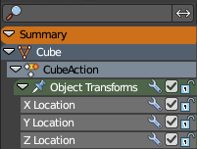
The channel list contains your objects and their animation channels. See also the different modes.

The channel list area can be resized by dragging the right border to left or right.

The list has several elements, to turn on or off different features, Or to expand or collapse the hierarchy.

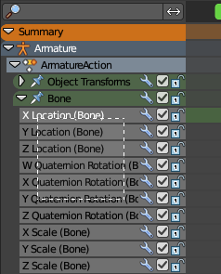
Hotkeys
Hotkey A selects all channels.
Hotkey Alt A deselects everything.
Left mouse and dragging activates box select.
Clicking at a channel selects it.
Clicking at a channel while holding down shift adds to the selection or removes from the selection.

Search field
At the top is a search field that allows you to filter the channel list by search terms.

Invert
Inverts the search result.

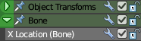
Expand / collapse triangle
The triangle icon at the left allows you to expand or collapse the hierarchy.

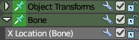
Pin
Keep the channels visible in Graph Editor for editing.

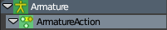
Object type Icon
This icon shows what kind of object this channel belongs to. These icons have no functionality.

Channel name
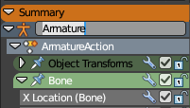
The name of the channel name and element. Some elements can be renamed. Like the action or object type.
To rename an element double click at it. Type in the new name. Then press Enter or click elsewhere.

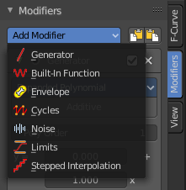
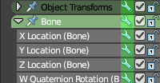
Enable F-Curve Modifiers
In the Graph editor you can add F-Curve modifiers. In the other animation editor types, like the Dope Sheet editor, you can enable or disable these modifiers by the Enable F-Curve Modifiers setting in the channel list.
For further informations about the F-Curve modifiers see the graph editor chapters.

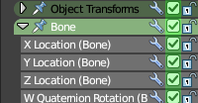
Mute Channel
Mutes the selected channel. It will not be calculated.

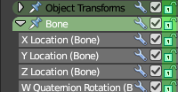
Lock Channel
Locks the selected channel. It is not longer editable.

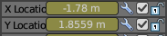
Slider values
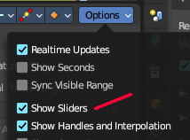
F-Curves can show a slider value in the channel list. This can be adjusted in the sidebar in the View options panel. Show Sliders is off by default.
You can edit these values. Double click to make it editable. Enter or click elsewhere to confirm. When you confirm, then the original keyframe gets updated.
When no keyframe exists at the current position, then this keyframe gets created.

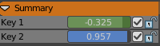
Shape key values
Shape key mode only.
In Shape key mode the channels shows the blend value. You can also edit it. Double click to make it editable. Enter or click elsewhere to confirm. When you confirm, then the original keyframe gets updated.
When no keyframe exists at the current position, then this keyframe gets created.

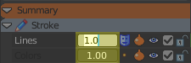
Opacity values
Grease Pencil only.
In Grease Pencil mode the channels shows the opacity values. You can also edit it. Double click to make it editable. Enter or click elsewhere to confirm. When you confirm, then the original keyframe gets updated.
When no keyframe exists at the current position, then this keyframe gets created.

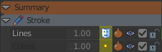
Mask Layer
Grease Pencil only.
Mask pixels from underlying drawing layers.

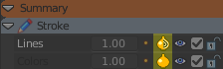
Onion Skinning
Grease Pencil only.
Display onion skins ghost frames from before and after the current frame.

